Final Report

Battle of the neighborhoods

Taimore Ikram Alvi

2020

Table of Contents

**Battle of the Neighborhoods - Capstone Project** 2

**Introduction:** 2

**Data** 2

**New York & Toronto Geo Data** 3

**Methodology** 3

**New York Data Set:** 3

**Toronto Set:** 5

**Using Four-Square API:** 9

**Clustering using k-Means (Machine Learning)** 10

**Results** 11

**New York Clusters** 12

**Toronto Clusters** 12

**Findings:** 12

Figure 1: New York Neighborhoods. 9

Figure 2: Toronto Neighborhoods 9

Figure 3: Segmented New York Neighborhoods. 12

Figure 4: Segmented Toronto Neighborhoods. 12

# **Battle of the Neighborhoods - Capstone Project**

## **Introduction:**

It is common for people to relocate to a new city or country for work. However, moving is not an easy task. Careful considerations need to be made considering the available options and accordingly a decision needs to be taken based on the pros & cons.

As part of this project, the neighborhoods in the city of New York in the US & Toronto in Canada are analyzed and segmented into clusters. Neighborhoods classified in the same cluster are similar & have similar features. Features are defined based on the venues & the venue categories which are available within a specified neighborhood radius. This will be further elaborated in the methodology section. Neighborhoods classified in different clusters are dissimilar & have dissimilar features. No comparison has been made between similar and dissimilar cluster of neighborhoods to suggest which one is better. The intention is only to cluster the neighborhoods in both cities into segments based on their venue / venue categories.

The objective here is for anyone considering to move from New York to Toronto or vice versa to identify the cluster that his neighborhood belong to and then find a similar cluster in Toronto which will offer him the equivalent features of his existing neighborhood.

This allows the user to benefit from machine learning clustering algorithms & take informed decision fully leveraging on the available data on the neighborhoods in the two major cities of US & Canada.

## **Data**

In order to accomplish the objective, geo data for both cities is required. The data for the cities of New York and Toronto have been sourced from 2 different sources. The data for both sources is available publicly. The data sources are defined below.

1. Toronto:
   1. List of postal codes, boroughs and neighborhoods obtained from Wikipedia. URL: <https://en.wikipedia.org/w/index.php?title=List_of_postal_codes_of_Canada:_M&oldid=942851379>
   2. List of postal codes along with their corresponding geo data (latitude & longitude) is obtained using the URL: <https://cocl.us/Geospatial_data>
2. New York:
   1. List of boroughs, neighborhoods along with their corresponding geo data (latitude & longitude) is obtained using the URL: <https://cocl.us/new_york_dataset>

Once the data is obtained, the four square API has been used to procure the venue details such as name & category of venues available in the neighborhoods.

Based on the data & the required goal a machine learning based clustering algorithm (k-means) will be used to process the data. The geo data for the city of New York & Toronto will be loaded into a panda’s data frame. The data frame used will essentially have 4 columns *namely* ***boroughs, neighborhood, latitude and longitude***.

### **New York & Toronto Geo Data**

The data for the city of New York is available as a JSON object which can be formatted based on the required data set format and loaded in the data set directly. The Toronto geo data however would be managed differently. Unlike the New York date, Toronto’s latitude and longitudes and available based on postal codes. Another data source provides us the borough & neighborhood based on a corresponding postal code. Therefore the Toronto data needs to be preprocessed and transformed before it can be used. As part of the project the 2 sources of Toronto data sets have been uploaded in two different data sets and then merged based on the index column of postal code which is the key to merge both data sets. Once the data is merged the Toronto data set contains 5 columns namely ***postal code***, ***boroughs, neighborhood, latitude and longitude.*** The postal code column is then dropped and data for both the Toronto and New York data set is copied to a new data set for consolidation. The data is also cleaned before it’s used in the ML model. Boroughs without any description are removed so the data is not polluted which may lead to misleading results.

Once the data from both sources is pre-processed and transformed it can be used for the ML clustering analysis. The final data set has 4 columns and includes boroughs and neighborhoods from both cities of New York & Toronto. The final data set’s composition is as below;

|  |  |  |
| --- | --- | --- |
| Serial | Column Name | Type |
| 1 | Borough | Str |
| 2 | Neighborhood | Str |
| 3 | Latitude | Float |
| 4 | Longitude | Float |

In order to use the data in our machine learning based clustering algorithm we would need to explore the venues available in the neighborhood. This is to be done using the four square API. With the four-square API our notebook will be connected using a four-square developer account & the venue in the specified radius of the neighborhoods will be extracted for the full data set and then used by our ML based clustering algorithm.

## **Methodology**

As covered under the data section, the coordinates for New York and Toronto were obtained from different sources. Once they were obtained **Exploratory Data Analysis** was done & the results are summarized below.

### **New York Data Set:**

Source: <https://cocl.us/Geospatial_data>

The data was available as a Json object & the data one read was parsed and only the relevant information required for the analysis (as specified under the data section) was loaded in a panda’s library. Below commands were executed as part of the exploratory data analysis.

|  |  |  |  |  |
| --- | --- | --- | --- | --- |
| S. No | Command & Results | | Notes | |
| 1. |  | Shows the first 5 records in the data frame. | |
| 2. |  | Dataset comprises of 306 observations and 4 characteristics. | |
| 3. |  | Data has only float and object (categorical) values/data types.  No variable column has null/missing values. | |
| 4. |  | Data has only 2 float columns for which various summary statistics are shown including the count, mean, standard deviation, minimum and maximum values and the quantiles of the data.  Since the nature of the float objects is coordinates as such there is no real value of the statistical analysis. | |
| 5. |  | There are 5 unique boroughs in New York.  Queens and Brooklyn have the highest number of neighborhoods with 81 and 70 respectively. | |

### **Toronto Set:**

Source: <https://en.wikipedia.org/w/index.php?title=List_of_postal_codes_of_Canada:_M&oldid=942851379>

The data was available on a Wikipedia page and the page had to be scraped for the data to be parsed and only the relevant information required for the analysis (as specified under the data section) was loaded in a panda’s library. Below commands were executed as part of the exploratory data analysis.

|  |  |  |  |
| --- | --- | --- | --- |
| S. No | Command & Results | Notes | |
| 1. |  | Shows the first 5 records in the data frame.  We can observe that there are records where a postal code is not assigned to any borough or neighborhood. |
| 2. |  | We observed that all dataset had all 3 object data types.  Dataset comprises of 287 observations and 3 characteristics.  There are 11 unique boroughs and 2019 unique neighborhood.  There are many instances where the borough and neighborhood are not assigned so such records should be dropped from the data set & such data can’t be used for clustering.  The command  **pd_toronto = pd_toronto[ pd_toronto['Borough'] != 'Not assigned' ]**  was used to drop all such records. |

Source: <https://cocl.us/Geospatial_data>

As you can observe in the above dataset the coordinates of the borough and their respective neighborhoods are not available. To access that information a second data set was used. The data was available there as a CSV file which was also loaded in a separate dataset for analysis. Below commands were executed as part of the exploratory data analysis.

|  |  |  |  |
| --- | --- | --- | --- |
| S. No | Command & Results | Notes | |
| 1. |  | Shows the first 5 records in the data frame.  We can observe this data set contains the latitude and longitude values for each postal code.  Postal code is the common value (index value) that can be used to merge the data from this data set to the old data set. |
| 2. |  | Dataset comprises of 103 observations and 3 characteristics.  Data has only float and object (categorical) values/data types.  No variable column has null/missing values. |
| 3. |  | Data has only 2 float columns for which various summary statistics are shown including the count, mean, standard deviation, minimum and maximum values and the quantiles of the data.  Since the nature of the float objects is coordinates as such there is no real value of the statistical analysis. |
|  | After standardizing the name conventions of the post code value, the 2 Toronto data set is merged & a single Toronto master data set is created which now combined the location data of the postal codes to their respective neighborhoods. The final data set is as follows; | |
| 4. |  | Shows the first 5 records in the data frame. |
| 5. |  | Dataset comprises of 210 observations and 5 characteristics.  Data has only float and object (categorical) values/data types.  No variable column has null/missing values. |
| 6. |  | Data has only 2 float columns for which various summary statistics are shown including the count, mean, standard deviation, minimum and maximum values and the quantiles of the data.  Since the nature of the float objects is coordinates as such there is no real value of the statistical analysis. |

At this stage we have prepared the New York & Toronto data sets separately & now they can be used for the clustering. In order to use the data, we can now merge the data sets together and standardize the columns of both datasets for the merging. This means that the postal code values which are only available in the Toronto data set have now become unnecessary & will be dropped. Below command is used to drop the postal code and merge the data in one single dataset.

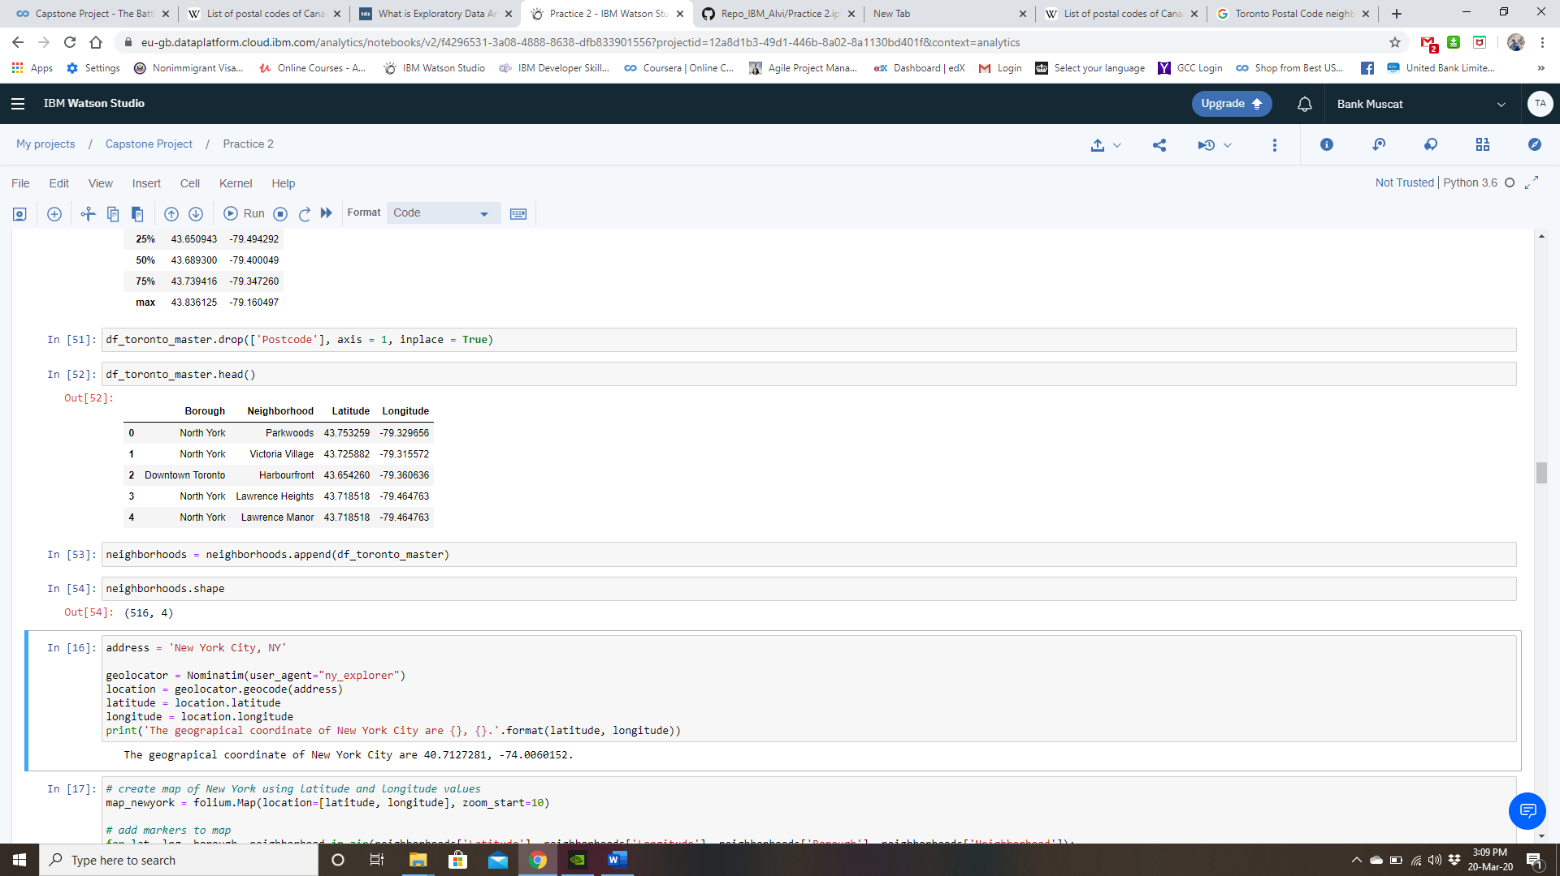

Our final data set has 516 observations and 4 characteristics which is line with the data format laid out under the Data section.

The final data set is plotted over the map to visualize that both Toronto and New York are covered and the outcome is as below;

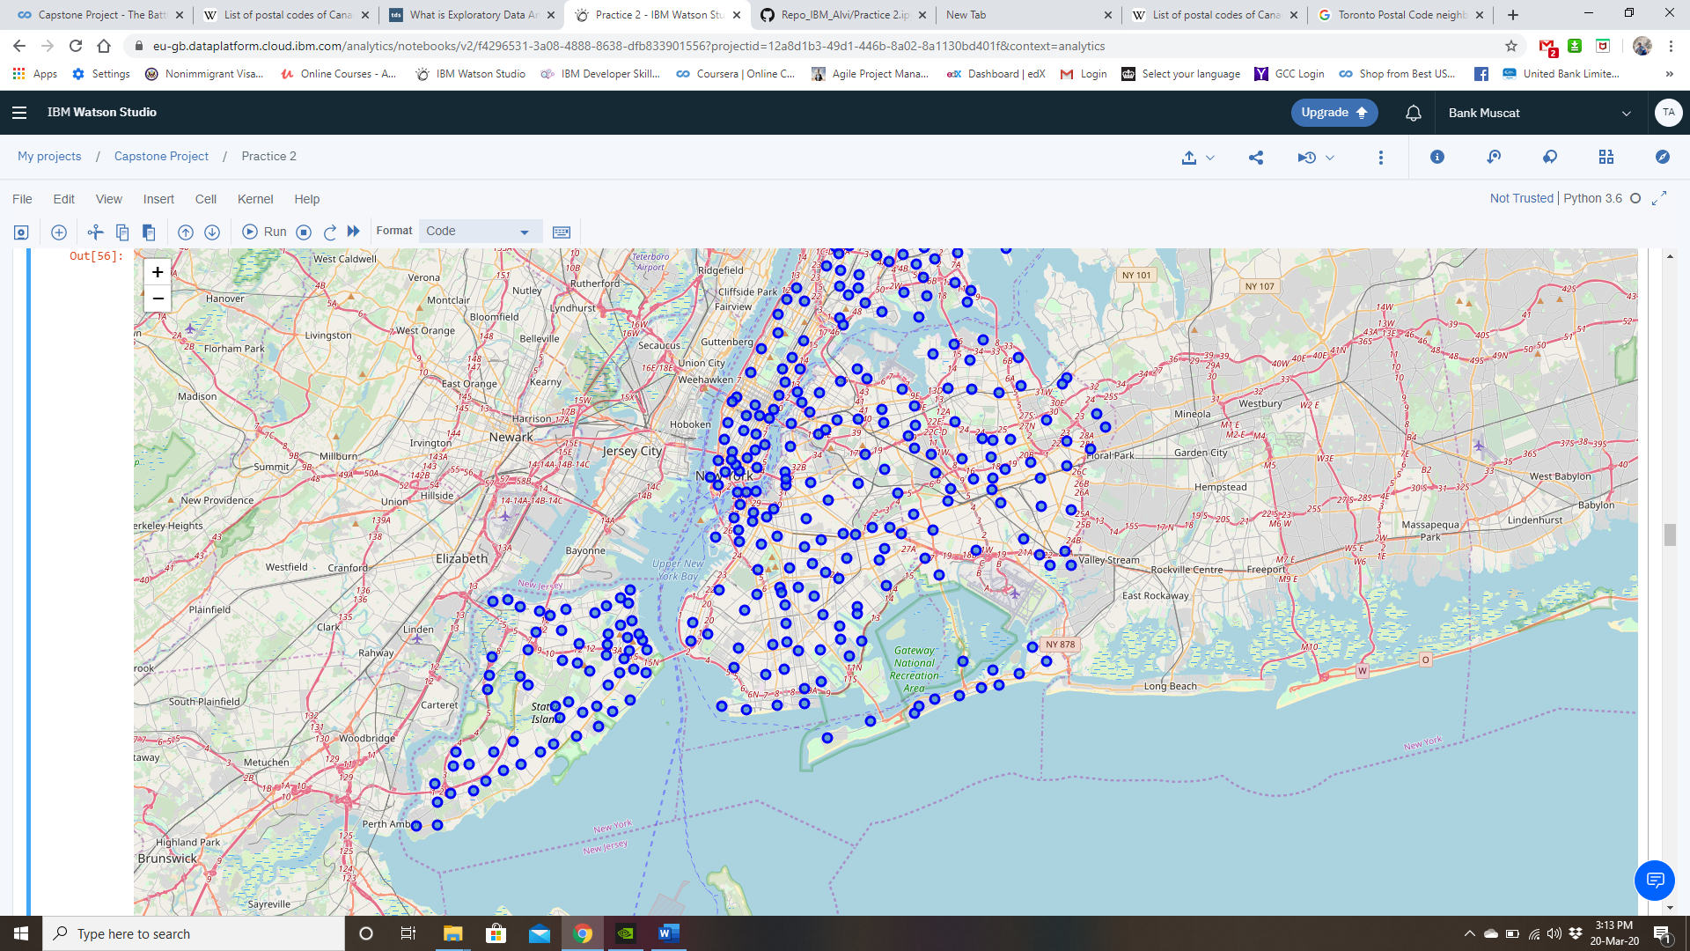

Figure : New York Neighborhoods.

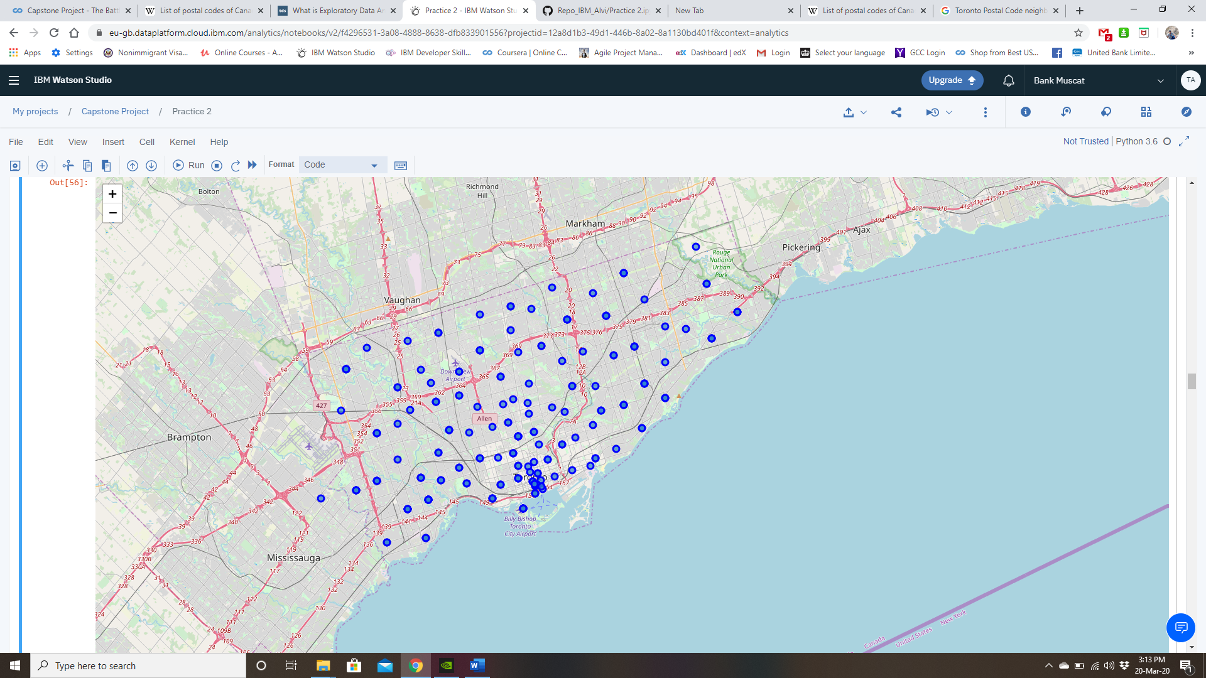

Figure : Toronto Neighborhoods

### **Using Four-Square API:**

As part of the methodology the next step now is to connect to the Four-square API and explore the neighborhoods of New York and Toronto. This is accomplished by having developer account credentials embedded in the notebook.

The ***explore*** command will be as part of the API and this command will be executed in loop for all of the neighborhoods in the 2 cities. We will be exploring 100 near by venues in a 500-meter radius of the coordinates. The venue name & venue category will be stored along with the neighborhood coordinates in a new dataset. This new data set is called ***all_venues.***

The resulting data set has a shape of (14605, 7) which implies that it has 14605 observations and 7 characteristics. The top 5 rows in the dataset are as follows;

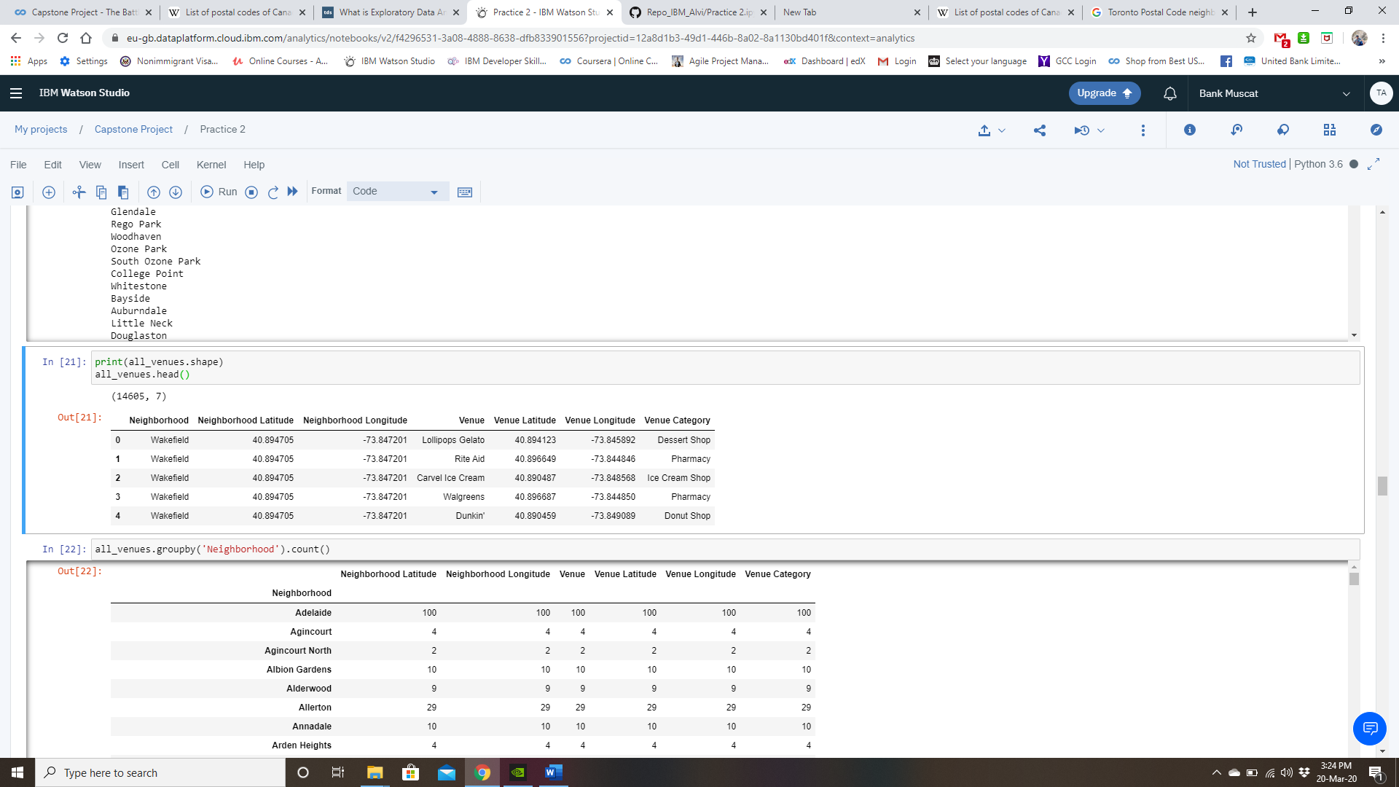

From the above data set we can observe that there are 5 venues *(Lollipops Gelato, Rite Aid, Carvel Ice Cream, Walgreens, Dunkin)* in the neighborhood of Wakefield. These venues have been classified into venue categories as well. The venue categories for these respective venues are *Dessert Shop, Pharmacy, Ice Cream Shop, Pharmacy & Donut Shop.*

Summarizing the data by neighborhoods will yield the below results;

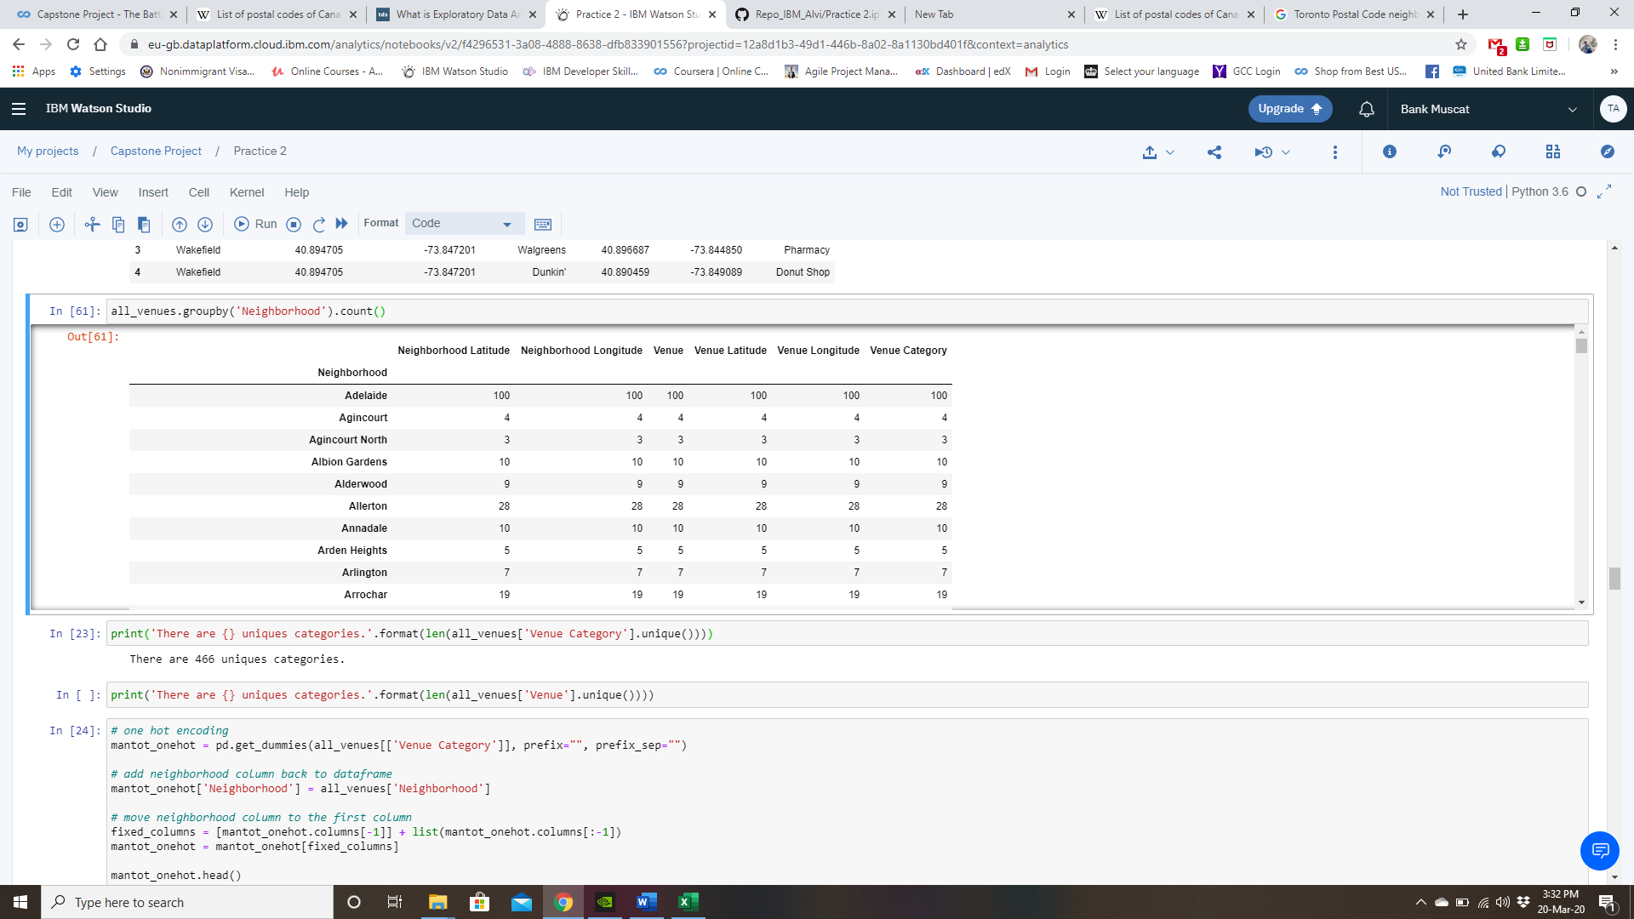

The above data shows that for the neighborhood of Adelaide, we are able to collect venue data for 100 locations however for the neighborhood of Agincourt, we were able to do it for only 4 locations. Overall, there are 468 unique venue categories & 9458 unique venues. This was observed using the below;

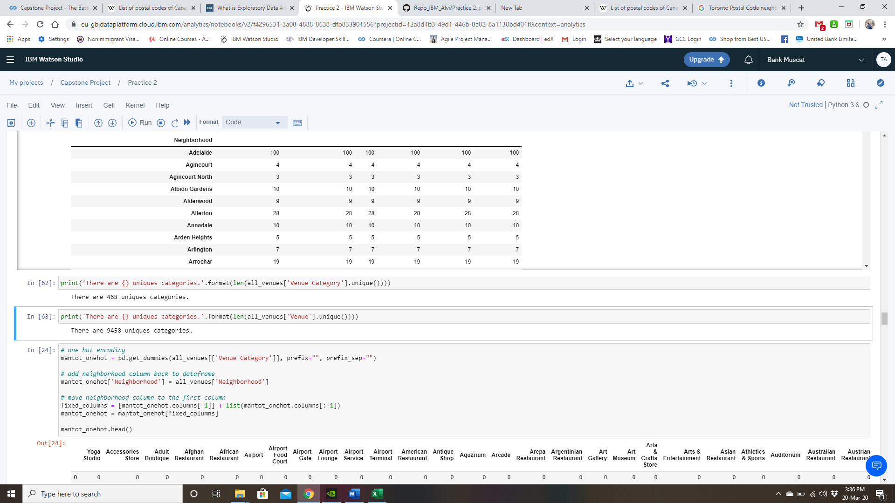

### **Clustering using k-Means (Machine Learning)**

In order to perform the clustering, we have to now use the machine learning algorithms. The Machine learning algorithms cannot work with categorical data directly. Categorical data must be converted to numbers. Therefore, we apply “**one hot encoding**” and prepare a new dataset which contains the venue category representations for each of the neighborhood.

After applying the one hot encoding, we store the resulting neighborhoods with their venue categories in a new dataset **mantot_grouped.** The shape of this dataset is (495, 468) which implies that there are observations available for 495 neighborhoods and 468 values (venue categories).

As we observed from the venues dataset that the number of venues varies from each neighborhood, some neighborhoods had a lot of venues while some had very few. Therefore, it makes sense that we consider only the top 10 venue categories for clustering in order to have meaningful results. As a next step, we filter our dataset to select the top 10 venue categories for each of the neighborhoods and we store the results in a new dataset **neighborhoods_venues_sorted.** Inquiring the first 5 rows of the dataset shows the below results;

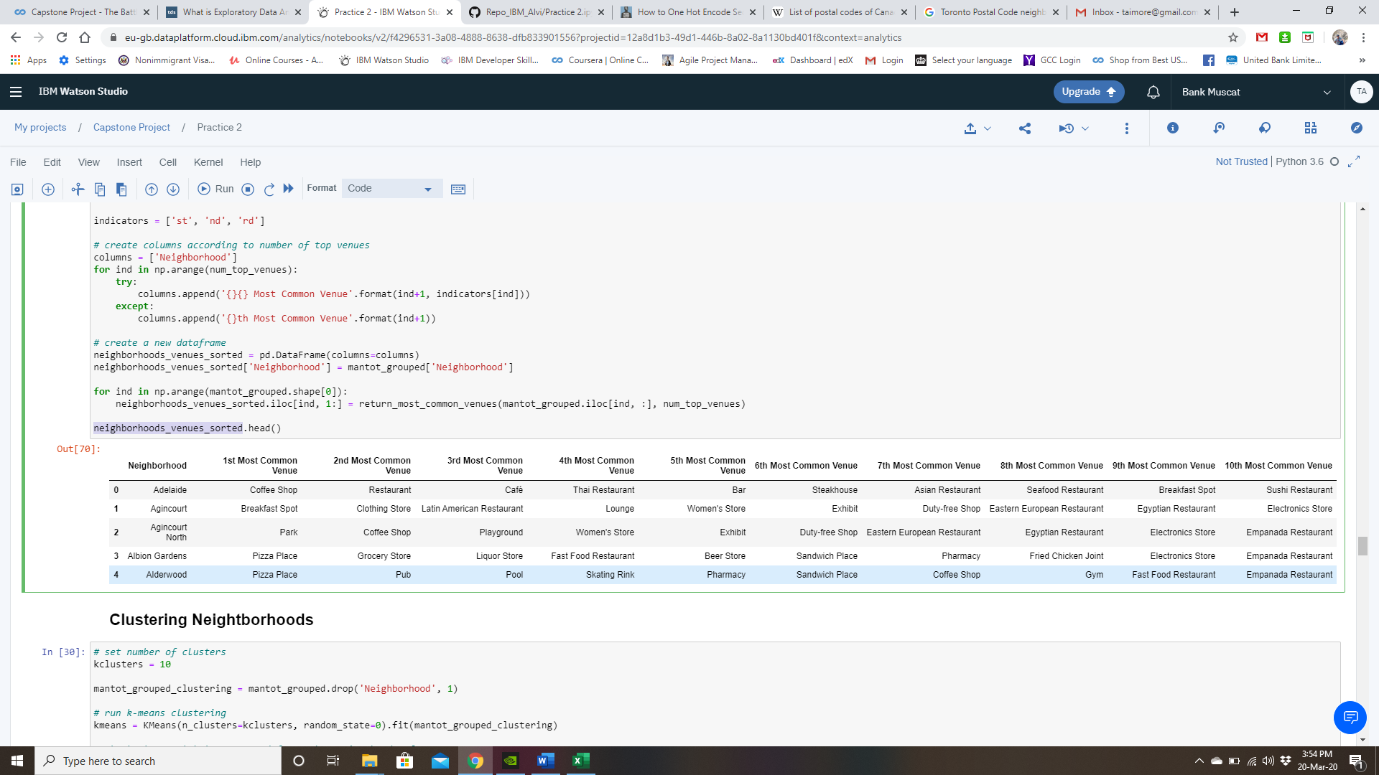

As it can be seen from the above dataset, the top 10 venue categories have been summarized for each neighborhood and the results are stored as a single row corresponding to each of the neighborhoods.

The k-Means clustering algorithm can now be used on the resulting dataset & we will use this machine learning algorithm to classify the data into 10 unique clusters. The clustered neighborhoods based on their venue category are stored in the dataset **neighborhoods_venues_sorted**. However, in order to visually represent the results, the data is merged with the earlier dataset **neighborhoods** which contains the coordinates of each borough & neighborhood of New York and Toronto. The merged data is stored in a dataset called **alldata_merged** which has the below first 5 records.

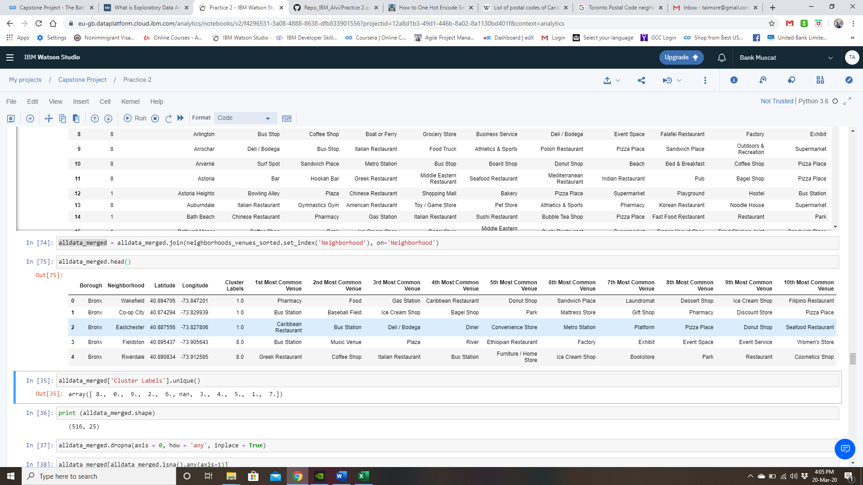

## **Results**

Now that we have the results of the clustering stored in a new dataset **alldata_merged** with the location coordinates, we check the unique clustering labels assigned by the machine learning algorithm k-means. There were 516 neighborhoods (*New York and Toronto combined*) & based on the objective we expect that every neighborhood has been classified into a cluster (label values 0 -9). If we check on the unique cluster labels, we observe the below;

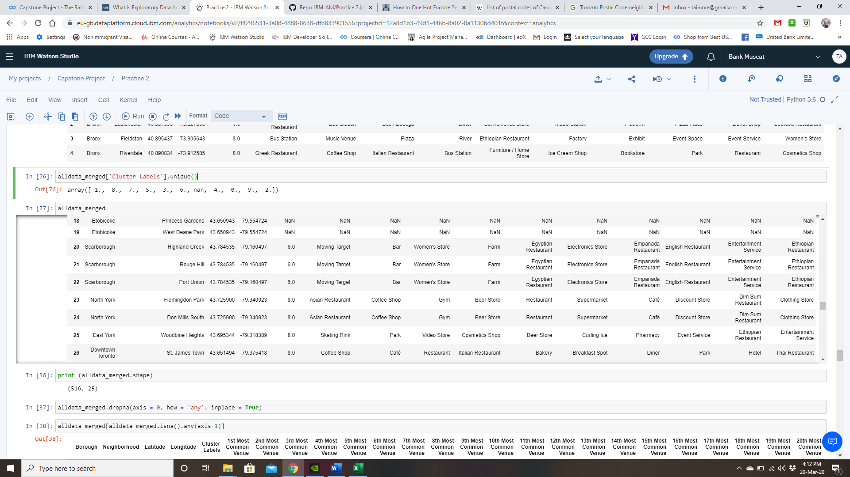

This implies that some neighborhoods could not be segmented into clustered. Such neighborhoods in our final data set have been given the value ***“nan”***. These are outlier values which may have been created due to the lack of venues/venue category data. Therefore, we still drop such outlier values in order to have meaningful results. After dropping such outliers, our shape of the resulting data set will be reduced to (506, 15). Therefore, we can conclude that there were 10 outlier neighborhoods (1 in New York and 9 in Toronto) in our data due to which our neighborhood count has reduced from 516 to 506.

Visual representation of the segmentation results is as follows;

### **New York Clusters**

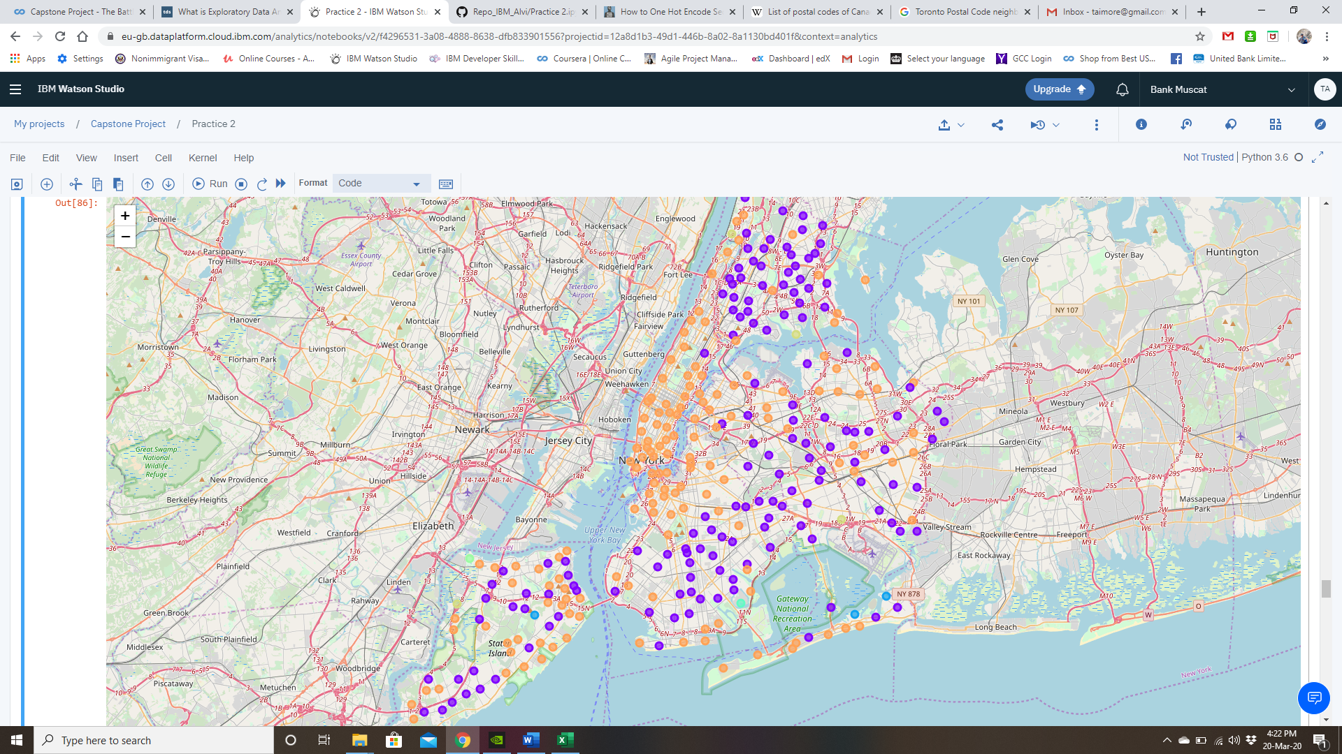

Figure : Segmented New York Neighborhoods.

### **Toronto Clusters**

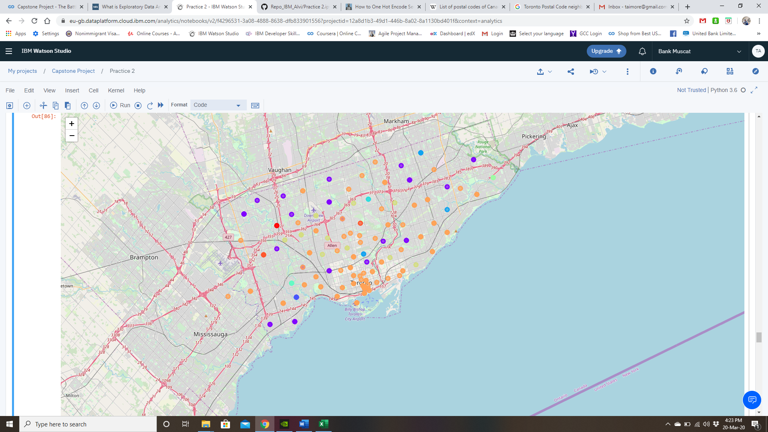

Figure : Segmented Toronto Neighborhoods.

### **Findings:**

1. New York neighborhoods have been classified into 6 segments.
2. The most popular segment is cluster # 8 which has 151 neighborhood(s) followed by cluster # 1 which has 145 neighborhood(s).
3. The least popular segment is cluster # 5 which has 1 neighborhood(s) followed by cluster # 6 which has 1 neighborhood(s).
4. Overall, the venue & venue categories are consistent in New York city due to which it many of its neighborhoods have been segmented in either cluster # 8 and # 1.
5. Neighborhoods classified in the remaining clusters are not as rich in terms of their venue & venue categories.
6. Toronto neighborhoods have been classified into 10 segments.
7. Unlike New York, Toronto neighborhoods are more unique in terms of their venue/venue categories.
8. The most popular segment is cluster # 8 which has 121 neighborhood(s) followed by cluster # 1 which has 36 neighborhood(s).
9. The least popular segment is cluster # 0 which has 2 neighborhood(s) followed by cluster # 4 which has 2 neighborhood(s).
10. Neighborhoods in Toronto are more diverse as compared to New York. That is one reason why Toronto can be segmented into 10 clusters while New York can only be segmented into 6 clusters.
11. There are 4 unique clusters which are only found in Toronto city. This suggests that while anyone moving from New York will be able to find a neighborhood which can be segmented based on their existing neighborhood, this will not be the case from anyone moving from Toronto to New York.
12. Residents of New York moving to Toronto will have an easier transition while the same may not be true for the residents of Toronto moving to New York city.